
TRIBHUVAN UNIVERSITY
Institute of Science and technology

A Project Proposal
On
“SewaGhar” – A smart home service booking platform

Submitted to
Department of Statistics and Computer Science
Patan Multiple Campus

In partial fulfillment of the requirements for Bachelor Degree in Computer science and Information Technology

Submitted By:
Aashika Bhandari, 28003
Sukriti Ghimire, 28126

Table of Contents
1. Introduction 1
2. Problem statement 2
3. Objectives 2
4. Scope of Project 3
5. Methodology 3
5.1 Requirement Identification 3
5.1.2 Functional Decomposition Diagram (FDD) 3
5.1.3 Study of existing system 4
5.1.4 Literature Review 5
5.1.3 Requirements Analysis 6
5.2 Feasibility Study 7
5.2.1 Technical Feasibility 7
5.2.2 Operational Feasibility 7
5.2.3 Economic Feasibility 8
5.3 High Level Design of System 8
5.3.1 Methodology of the proposed system 8
5.3.3 Use Case Diagram : 10
5.3.4 Description of algorithms 14
6. Work Plan 15
Gantt chart 15
7. Expected outcome 16
8. References 16

List of figures
Figure 1: Flowchart for users, service providers, admin……………………………….9,10
Figure 2: Use case diagram for user Management…….……………………………….11
Figure 3: Use case diagram for Employee Management…….…………………….….12
Figure 4: Use case diagram for Booking Management…….………………………….13

Abstract
Project "SewaGhar " aims to develop a housing creation platform to connect users with reliable service providers for different domestic needs. In today's sharp-transport environment, finding people who are capable of domestic work provides an important challenge. This platform wants to address it by providing user -friendly and effective systems for both customers and service providers.

The platform will enable uninterrupted registration and profile administration for both users. This will include a matchmaking system so that users are combined with appropriate service providers depending on their specific requirements and location. The goal is to order and create a transparent and safe environment for ordering and planning services, which increases the user's trust.

The system will be designed to be responsible for different devices, including mobile phones, tablets and desktop machines. In addition, architecture will be scalable and maintenance to meet future expansion. Finally, “ SewaGhar” intends to offer a reliable and secure platform that protects user data and promotes trust in service seekers and suppliers.

Introduction
In today's fast -paced world, handling domestic functions and finding reliable service providers can be an important challenge. In addition, skilled individuals often seek available platforms to provide their expertise and contact potential customers. To meet these needs, we propose the development of “SewaGhar”, a comprehensive service and management system designed to be originally designed to connect users seeking help with a network of qualified service providers.

“SewaGhar” will serve as a user -friendly platform where individuals can easily request and perform safe services such as house painting, elderly care/childcare, cooking & catering, beauty services, home tutors, event planners, plumbing and electrical work. In addition, the scene will allow skilled people the opportunity to sign up as service providers/employees, who will provide their services to extensive target groups and create valuable employment opportunities.

The project aims to create a streamlined and efficient ecosystem that simplifies the process of achieving domestic services by providing a platform for service providers, providing a platform to increase its reach and manage its work efficiently. By reducing the gap between demand and supply, we promise to be a valuable resource for both users and service people in society.

Problem statement
It is often disappointed and disabled to find reliable home service providers, while skilled workers are also struggling to join customers. The project deals with the difference with a centralized platform that simplifies the process for both users and service providers in home care and maintenance services.
Problem Declaration:
- Hard to find help -Fragmented access users are struggling to find reliable help due to scattered platforms and referrals with the word-off mouth.
- Incredible quality - the lack of openness in prices, service quality and planning provide user stress.
- Limited access to suppliers - skilled workers have difficulty marketing themselves and finding constant work.
- Disabled existing platforms - can use or fail to support the needs of current equipment suppliers effectively.
- Need for one simple system - There’s a strong need for a single, easy to use system that connects users with trustworthy and skilled service providers.

Objectives
Our primary objectives are:
- Easy connection system: Create a user -friendly platform for users, so that they search for different homes and personal care services.
- Strong service provider: Individuals provide a dedicated place to register, demonstrate their skills and get in touch with potential customers.
- Streamline Service Administration: Develop equipment for efficient planning, communication and transaction management for both users and suppliers.
- Increase service access: Provide a practical and accessible option for traditional ways to find and offer services.
- Build a trusted community: Building a reliable society uses marketing a reliable environment through functions such as reviews and supplier profiles.
- Offer a diverse category of services: Complete a comprehensive range of needs, including painting, care, cleaning and effective trades.

Scope of Project
“SewaGhar” is an online service and management system designed to easily connect users with effective local suppliers. The platform will allow users to register service providers, manage their offers and join customers, let users find and ask for services effectively. The goal is to create a reliable and well -organized market that benefits both service seekers and suppliers.

Methodology

5.1 Requirement Identification
Requirement identification is the gathering of relevant requirements that will be used to develop a system. There are different methods to gather requirements which include studying existing systems, interviews, questionnaires etc.

5.1.2 Functional Decomposition Diagram (FDD)

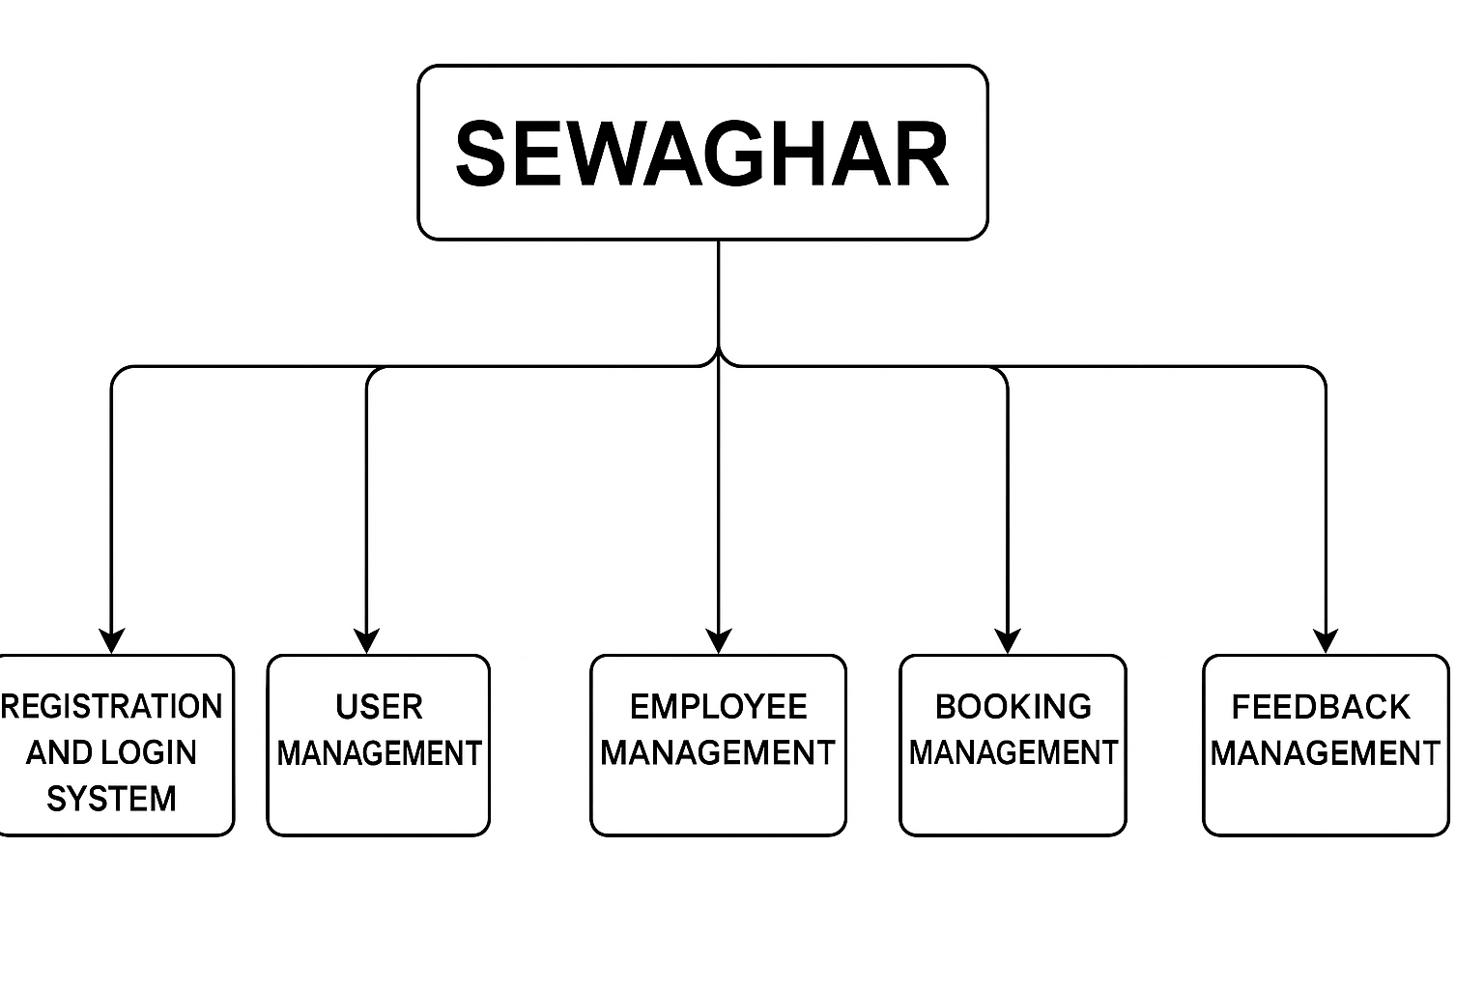

The above figure shows the breakdown of the different artefacts/ sub systems of my project “SewaGhar”. The diagram highlights the major functions or processes to be carried out or performed. The FDD also highlights the scope and boundaries of my project, what it aims to complete and what are its limitations.
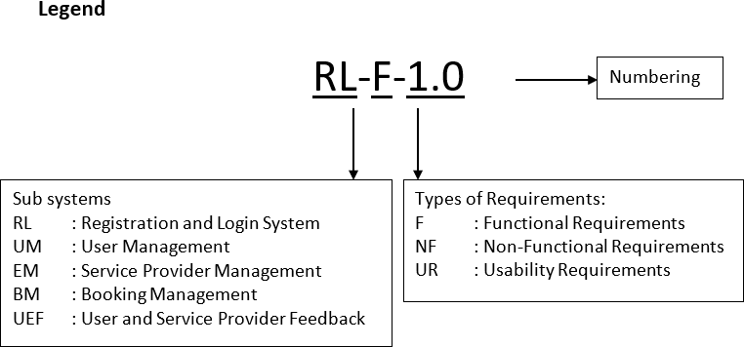

5.1.3 Study of existing system
In order to gain a deeper understanding of the current landscape and user expectations, it is necessary to analyze the same service-based platforms as users connect to home and individual care providers. Applications such as Hamro Sewa, Sewa App – Service at Your Doorsteps [Facebook page] are popular and are widely used to offer home services.
These platforms provide different types of useful features such as:
- Service classification by working type and urgent.
- Ranking and reviews.
- Planning and real-time support.
- Secured payment.

5.1.4 Literature Review
Authors | Country | Type of Source | Summary of Points
M.A. Berlin, B.A. Ramesh, C. Venkata Sai, K. Maneesh Reddy | India | Journal Article | The article highlights the significance of online home services, proposing an app-based system to connect skilled providers with users for various home maintenance tasks.
Hafiz Adil Sikandar, Shahbaz Musahbar, Shahan Yamin Siddiqui, Arslan Abbas, Tajammal Hussain Awan | Pakistan | Research Paper | The research paper introduces an Android Handyman Services application, predicting significant growth in Pakistan’s mobile software industry, aimed at connecting users with skilled workers.
Nutakki & Mandava | Various | Systematic Literature Review | Identified gaps in Home Energy Management Systems (HEMS), emphasizing the importance of incorporating user behavior, data protection, and local-level energy trading to enhance practicality and scalability.

Existing literature establishes the importance of mobile-first, scalable solutions for home services. However, there's a notable gap in localized platforms tailored to Nepalese users that ensure trust, cultural familiarity, and multi-role coordination. SewaGhar aims to fill this gap with a balanced, community-first approach.

5.1.3 Requirements Analysis
Requirements for the “SewaGhar” platform will be gathered through analysis of existing service marketplaces, consideration of user needs (both service seekers and providers), and a focus on creating a user-friendly and efficient system.

Functional Requirement
  - Safe user approval: Login, registration, login for users and suppliers.
  - User profiles: Management of information related to personnel and service.
  - Service Discovery: Browse category, search for search/location, see supplier profiles.
  - Requests and orders: Submit the request, see the supplier, start ordering, confirmation system.
  - Communication: Direct messages between users and suppliers.
  - Payment processing: Secure online payment, tracking payment history.
  - Ranking and reviews: User supplier, public visibility of assessment.
  - Supplier management: Manage services, accessibility, prices, ordering, earnings.
  - Basic Administrator: User/Supplier Overacted, Service Category Administration.

Non-functional Requirement
They define how the system will work.
- UX/UX with user -friendly and intuitive UX: The site must have a clean, easy to navigate interface available for a wide range of users.
- Responsible design: The site should effectively work and function in different devices (desktop machines, tablets and potential mobile browsers).
- Safe platforms: Strong security measures to protect user data and financial transactions.
- Scalability: The system should be designed to handle the growing number of users and service providers.
- Reliability: The scene must be stable and consistent.
- Performance: The site should be loaded quickly, and the user should respond effectively to user tasks.
- Clear Privacy Policy: Transparent and user -friendly privacy rules on data management.

5.2 Feasibility Study
It is a study of how well the system will function under the given constraints. It studies how easy it is to build a system under given constraints. The constraints include operational feasibility, economic feasibility, and technical feasibility.

5.2.1 Technical Feasibility
The system is technically feasible because it uses reliable and well-supported technologies. The frontend is built with HTML, CSS, JavaScript, and Bootstrap, ensuring a responsive and user-friendly interface. The backend uses Django, a powerful Python framework known for its security, scalability, and fast development capabilities. These tools make the system efficient, stable, and easy to maintain.

5.2.2 Operational Feasibility
The proposed system is in good agreement with operational feasibility. Standard browsers on both platforms, mobile and desktop devices are available, ensure comprehensive and spontaneous user experience for both service seekers and suppliers. The main functionality for management of services, users and ordering can be effectively maintained by the reason by the reason, which makes the ongoing operation practical and manageable.

5.2.3 Economic Feasibility
The platform is economically viable as it is free to use for both users and service providers. However, users are required to pay a partial amount upfront when booking a service. This approach keeps the service affordable for users while ensuring fair compensation for providers, making the system financially sustainable.

5.3 High Level Design of System
This section describes the blueprint of the system, focusing on its behavior and user interface.

5.3.1 Methodology of the proposed system
The development of the platform will follow Scrum Framework, which is a subset of the Agile methodology. This approach emphasizes recurrent growth, cooperation and rapid adaptation to ensure the manufacture of a valuable and user -centered product. The most important items in our Scrum function include:
- Iteratives and incremental development: Facilities will be developed and distributed in wage increases (sprint), which allows for continuous integration and reaction incision. For example, user registration and login can focus on an initial sprint, followed by service in the next service.
- Sprint cycle: Development will be held in a brief repetition of a time box called sprint (e.g. two weeks of sprinter). Each sprint will aim to distribute the potential useful growth on the site. The Associates and Reaction Regular Communication and Cooperation will be within the development team and with stakeholders. The response from potential users will be actively sought and integrated to ensure that the platform effectively meets their requirements.
- Sprint Review: To present the entire work to stakeholders and gather feedback.
- Sprint Retrospective: To reflect on the previous sprint and identify areas to improve the process.

5.3.2 System Flowchart :
User Flowchart
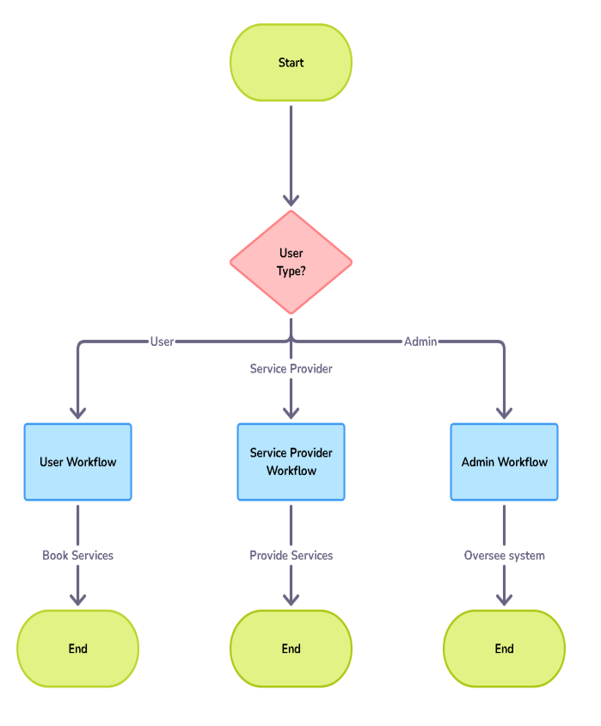
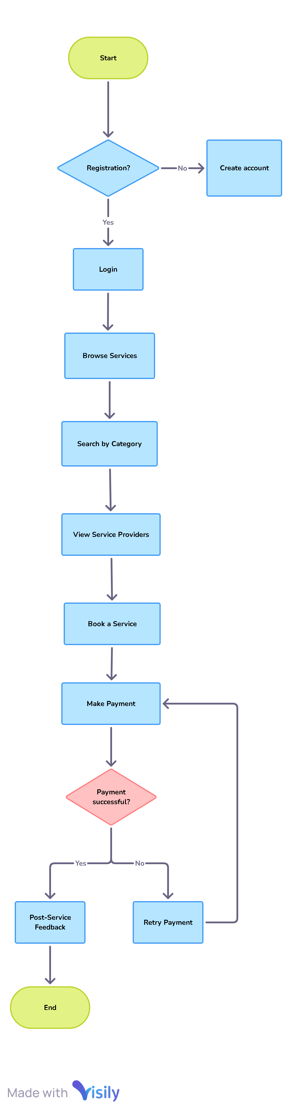
Figure 1

Figure 2

Admin Flowchart
Service Provider Flowchart
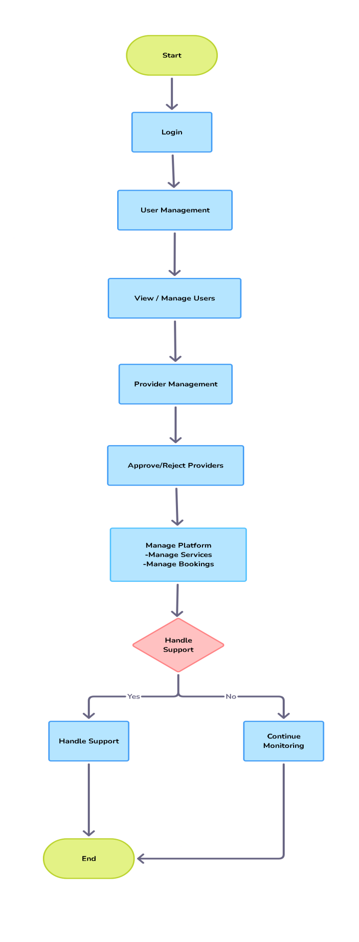
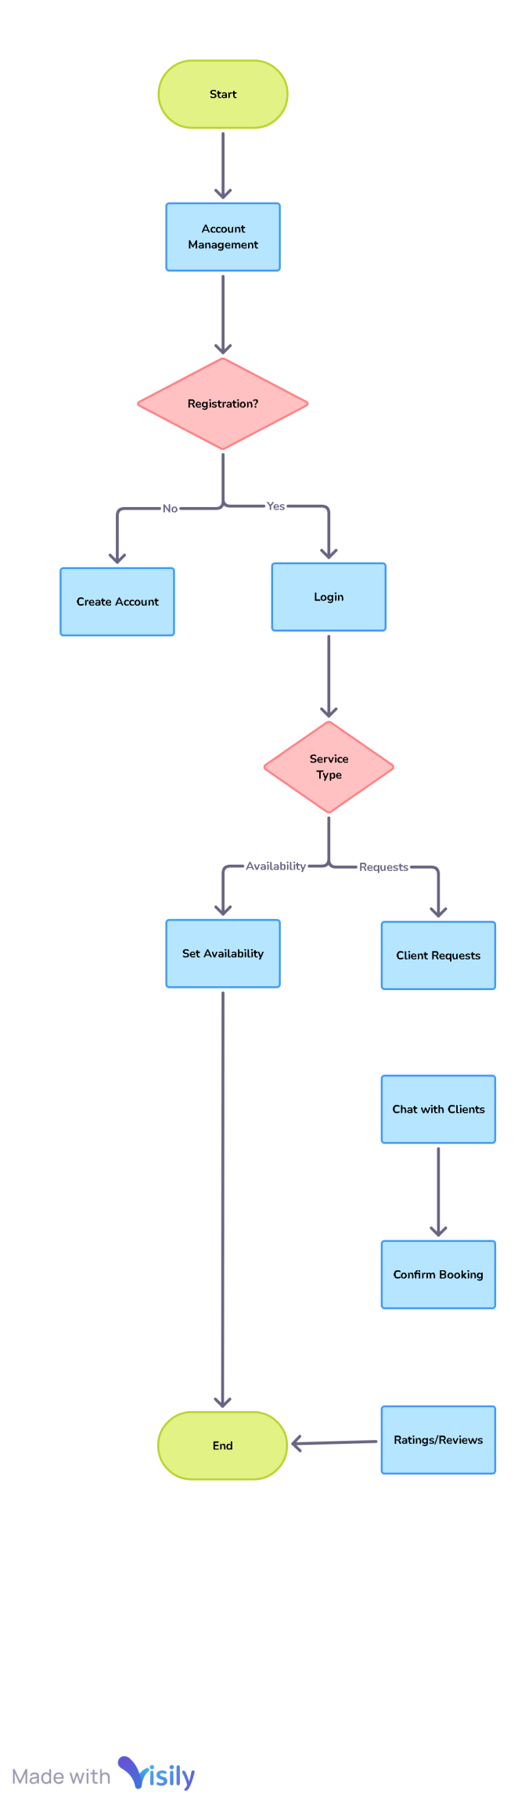

Figure 4
Figure 3
5.3.3 Use Case Diagram :
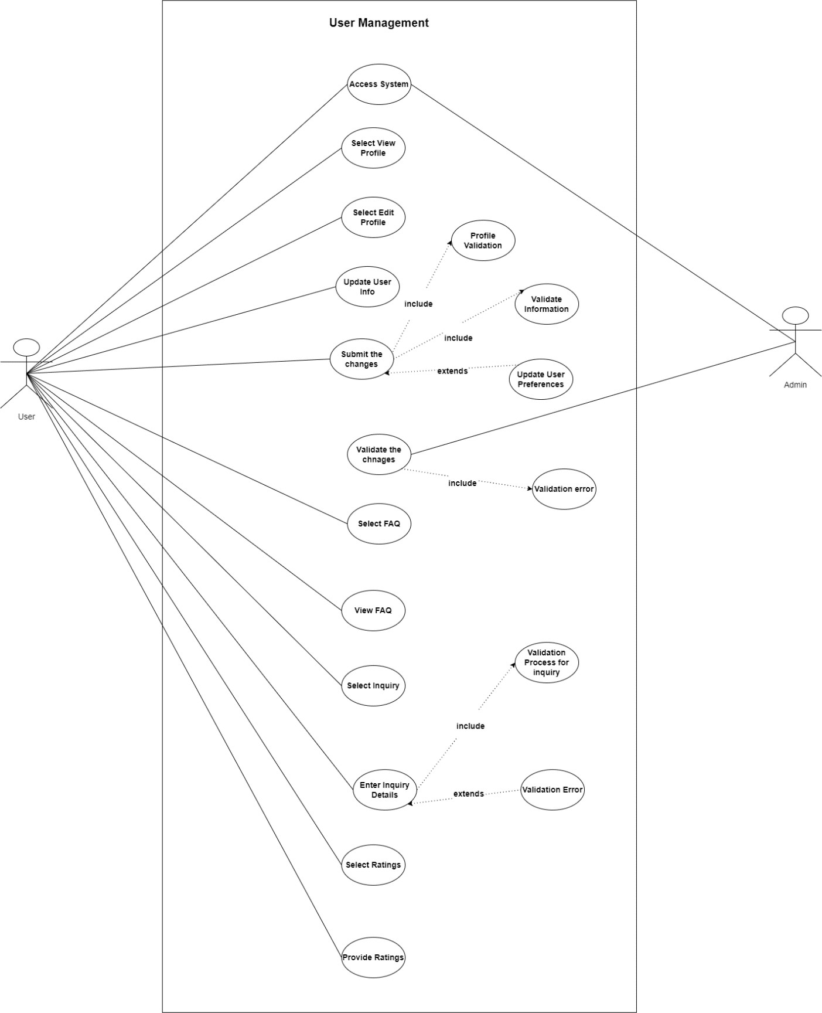
User Management: The diagram below is the use case diagram for user management artefact. User and admin are the two actors participating in the use case. The use case describes the flow of the user actions. The user actions are highlighted as users can view and edit their respective profiles and also send inquiries to the admin.
Figure 5: Use Case -UM

Employee Management:
The above diagram is the case diagram for employee management artefact. Employee and Admin are the two actors participating in the use case. The use case describes the flow of the employee actions. The employee actions are highlighted as they can view and edit their respective profile. Admin can also manage the tier of the employee.
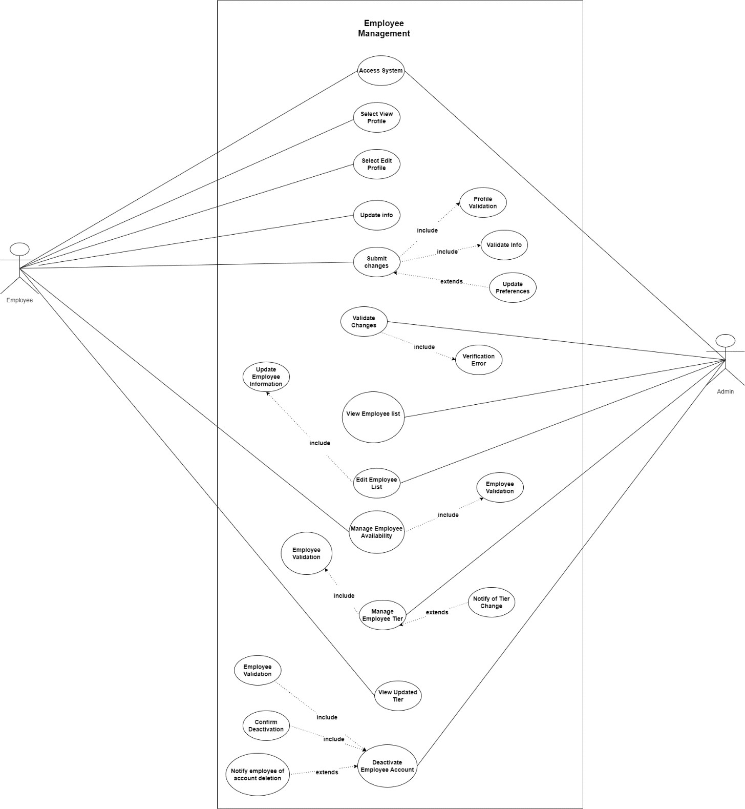
Figure 6: Use Case -UM
Use Case-BM:
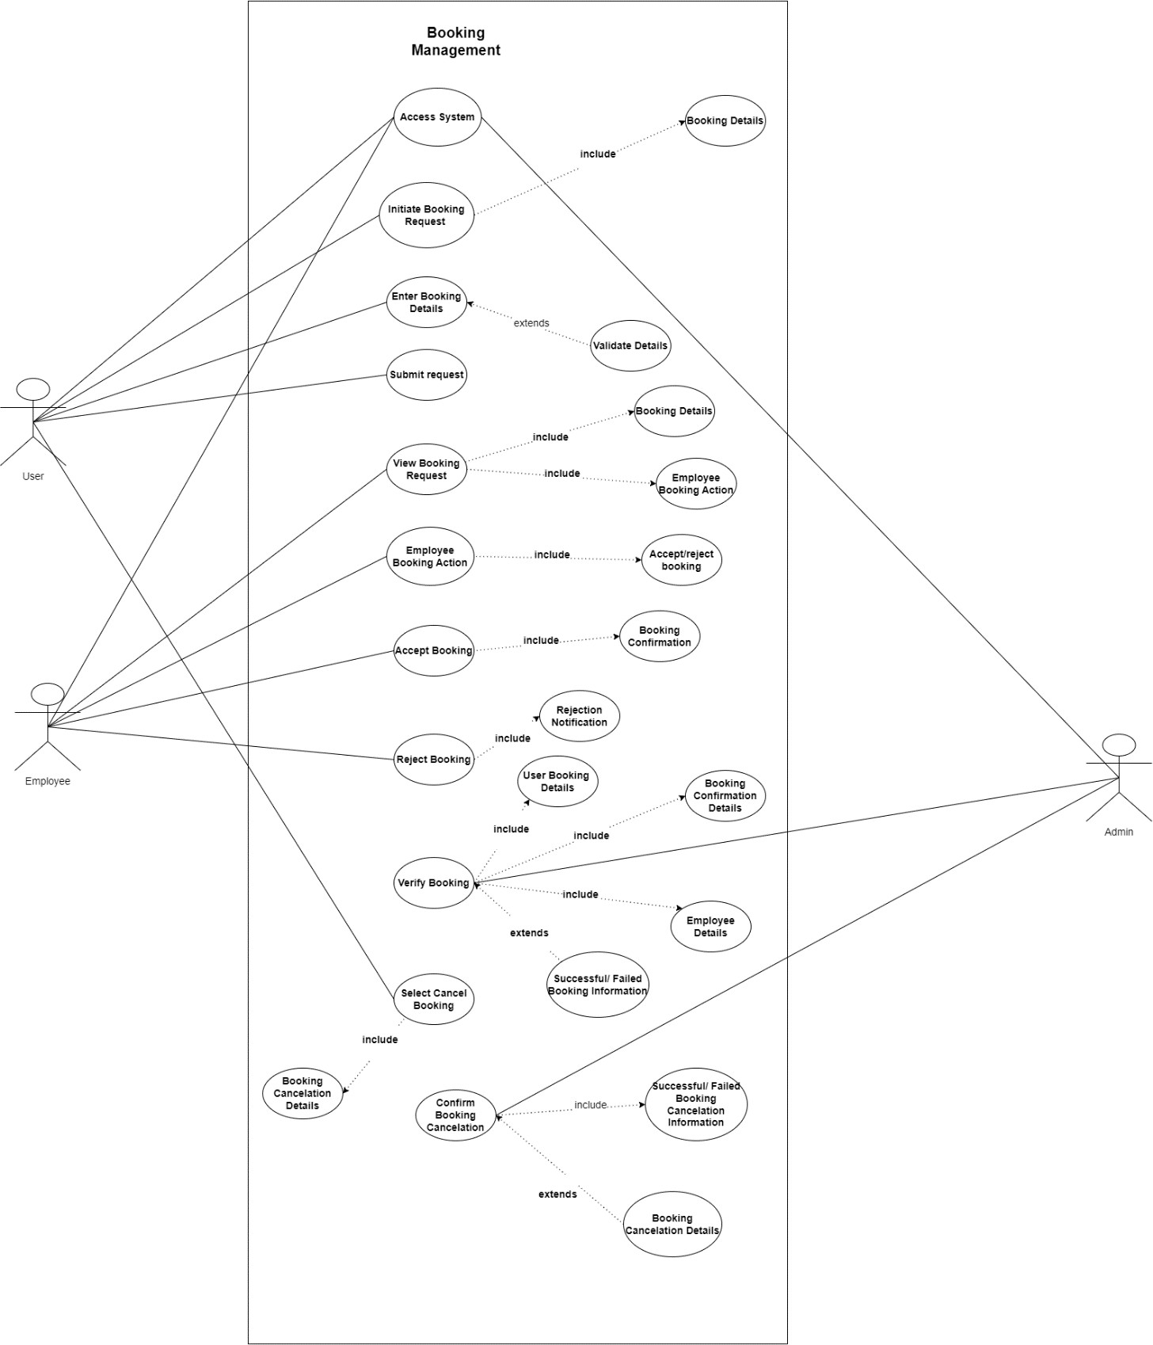
The use case below shows the flow of booking management artefacts. Users and employees are the two actors in the use case. The flow helps us to understand how booking management works in this system.
Figure 7: Use Case- BM

5.3.4 Description of algorithms
The main functionality of the system depends on being skilled, matching service requests from users with appropriate service providers who consider many real-world factors. To achieve this, the system implements a weighted match and planning algorithm that evaluate potential match based on the following criteria:
- Distance: Priority to the user's close service providers to reduce the journey and costs.
- Separate Match: Adapts to the type of service that is asked to the service provider's skills.
- Availability: The user's requested time matches the supplier available under the track.
- Provider assessment: Average user assessment to prefer reliably and supplier to a high degree.
- Foundation Balance: Service requests equally between suppliers to prevent overload and ensure timely service.

The algorithm calculates a compatibility score (S) for each candidate service provider using the formula:
S =w1​×fdistance​+w2​×fskill​+w3​×favailability​+w4​×frating​+w5​×fload​
Where:
- fdistance​: Normalized inverse distance score (closer providers get higher scores).
- fskill​: Skill match score (1 if skills match, otherwise 0 or scaled based on proficiency).
- favailability​: Availability indicator (1 if available at requested time, 0 if not).
- frating​: Normalized average provider rating score.
- fload​: Inverse of current workload to promote even distribution of tasks.
- w1,w2...,w5​: Weight factors assigned to prioritize each criterion based on business needs.
The system selects the provider with the highest compatibility score to fulfill the user’s service request.

Why This Algorithm?
This approach allows the system to consider several important factors at the same time, resulting in a balanced, fair and efficient matchmaking process. This improves the user's satisfaction by offering timely and relevant service providers and ensures fair job distribution among service providers. In addition, the modular nature of the algorithm provides easy adaptation and scalability as the platform increases.

Work Plan

Gantt chart
Table 1: Gantt chart for “SewaGhar”
Process | 1 | 2 | 3 | 4 | 5 | 6 | 7 | 8 | 9 | 10 | 11 | 12
Requirement Gathering
Planning
Designing
Coding
Testing & Debugging
Implementation

Expected outcome
The system is expected to provide:
- A spontaneous and user -friendly platform to manage various domestic services efficiently and reach them.
- Both service providers (employees) and uninterrupted registration and profile administration for customers.
- A reliable matchmaking system that combines users with appropriate service providers depending on their needs and location.
- User -safe, transparent and even ordering and planning services to increase the system.
- Responsible design that ensures access to equipment including mobile, tablet and desk.
- A scalable and maintenance system architecture that supports future functional extension.

8. References
- Ghimire, S. & Shrestha, R., 2021. Nepal Journal of Web and Mobile Technologies. "Hamro Sewa": A Mobile Platform to Connect Nepali Freelancers with Local Job Seekers, 3(2), pp. 45–58.
- Sewa App. (n.d.). Sewa App – Service at Your Doorsteps [Facebook page]. Facebook. Retrieved May 25, 2025, from https://www.facebook.com/sewaapp1/
- M.A.Berlin, B. ,. C. S. ,. K. R., 2021. Annal" for the service booking and management website and also provide 2/3 website in contex of Nepal
- Hafiz Adil Sikandar, S. M. Y. S. A. H. A., 2022. PALARCH'S JOURNAL OF ARCHAEOLOGY OF EGYPT / EGYPTOLOGY. COMPARATIVE ANALYSIS AND HANDYMAN SERVICES APPLICATION DEVELOPMENT, 19(3), pp. 160-199.

